HEALTHCARE WEBSITE

**A PROJECT REPORT**

***Submitted by***

**1.Mansaa Narang** (21BCE10510)

**2.Anshika Agrawal** (21BCE10449)

**3.Jyotiraditya Patil** (21BCE10496)

**4.Priyanshu Agnihotri**(21BCE11637)

**5.Ayush Karkare**(21BCE10517)

*in partial fulfillment for the award of the degree*

*of*

**BACHELOR OF TECHNOLOGY**

*In*

COMPUTER SCIENCE AND ENGINEERING



**SCHOOL OF COMPUTING SCIENCE AND ENGINEERING**

**VIT BHOPAL UNIVERSITY**

**KOTHRIKALAN, SEHORE**

**MADHYA PRADESH – 466114**

MONTH AND YEAR:-FEB 2023

**BONAFIDE CERTIFICATE**

Certified that this project report titled **“ Health Care Website And BMI Framework ”** is the bonafide work of “ **Mansaa Narang (21BCE10510), Anshika Agarwal(21BCE10449), Priyanshu Agnihotri(21BCE11637), Jyotiraditya Patil(21BCE10496) , Ayush Karkare(21BCE10517)”** who carried out the project work under my supervision. Certified further that to the best of my knowledge the work reported here does not form part of any other project / research work on the basis of which a degree or award was conferred on an earlier occasion on this or any other**.**

**PROJECT SUPERVISOR**

**Dr. L.Satish Kumar**

**School of Computer Science and Engineering**

**VIT BHOPAL UNIVERSITY**

**ACKNOWLEDGEMENT**

First and foremost I would like to thank the Lord Almighty for His presence and immense blessings throughout the project work.

I wish to express my heartfelt gratitude to Dr Sandip Mal, Head of the Department, School of Computer Science And Engineering for much of his valuable support encouragement in carrying out this work.

I would like to thank my internal guide Dr.L.Satish Kumar,for continually guiding and actively participating in my project, giving valuable suggestions to complete the project work.

I would like to thank all the technical and teaching staff of the School of Computer Science And Engineering, who extended directly or indirectly all support.

Last, but not the least, I am deeply indebted to my parents who have been the greatest support while I worked day and night for the project to make it a success.

|  |  |  |
| --- | --- | --- |
| **CHAPTER NO.** | **TITLE** | **PAGE NO.** |
|  | Abstract | **6** |
| 1 | **INTRODUCTION**   * 1. Introduction   2. Motivation for Work   3. Problem Statement   4. Objective of the work | 7  9  10  11 |
| 2 | **LITERATURE SURVEY**  2.1. Introduction  2.1.1. Research issues/observation from literature survey  2.1.2. Summary | 13  15  16 |
| 3 | **SYSTEM ANALYSIS**  3.1 Introduction  3.2 Proposed System  3.3.1. Hardware Requirements  3.3.2. Software Requirements | 18  19 |

|  |  |  |
| --- | --- | --- |
| 4 | **SYSTEM DESIGN AND IMPLEMENTATION**  4.1 Modules used  4.2 Workflow  4.3 Implementation | 20  23  26 |
| 5 | **PERFORMANCE ANALYSIS**  5.1Performance Analysis of BMI Website  5.3 Performance Analysis of BMI framework | 28  29 |
| 6 | **FUTURE ENHANCEMENT AND CONCLUSION**  6.1Introduction  6.2 Limitation/Constraints of the System  6.3 Future Enhancements  6.4 Conclusion | 30  31  32  33 |
|  | References | 35 |

**ABSTRACT**

Our website is designed to help you achieve a healthy lifestyle by providing a simple BMI calculator and personalized diet and yoga recommendations based on your BMI. By inputting your height and weight, our calculator quickly generates your BMI, allowing you to determine whether you are underweight, normal weight, overweight, or obese. Based on your BMI, we offer diet and yoga asana recommendations to help you maintain a healthy weight and promote overall well-being. With our user-friendly platform, you can easily access the resources you need to achieve your health and fitness goals. Take the first step towards a healthier you with our website today.

Our innovative BMI Framework uses facial recognition technology to accurately calculate your BMI. Simply upload a photo of your face, and our algorithm quickly generates your BMI, allowing you to determine your ideal weight range. Our platform offers a fast and convenient way to monitor your health and achieve your weight goals.

* The website offers a range of health benefits by providing users with a comprehensive diet plan and yoga asanas. These can help users to maintain a healthy weight, improve their physical fitness, and reduce their risk of developing chronic illnesses.
* The website also carries the potential risk of users becoming overwhelmed by the amount of information available, leading to confusion and frustration.

The website has the potential to have a positive impact on users heal

**INTRODUCTION**

Welcome to our website, where you can easily calculate your Body Mass Index (BMI) and get personalized recommendations for diet and yoga asanas based on your BMI.

BMI is a measure of body fat based on your weight and height. By using our user-friendly BMI calculator, you can determine your BMI and learn whether you are underweight, normal weight, overweight or obese. This information is crucial in understanding your health status and in planning a course of action to maintain or improve your well-being.

Based on your BMI, we offer personalized diet and yoga asana recommendations that are designed to help you achieve your health and fitness goals. We believe that a balanced diet and regular physical exercise are essential for maintaining a healthy lifestyle, and we want to help you make the best choices for your unique body type and fitness level.

Our team of nutritionists and yoga experts have created a range of diet and yoga plans that are tailored to different BMI categories. For example, if you are underweight, we offer diet plans that can help you gain weight in a healthy way. For those who are overweight or obese, we have created diet plans that promote weight loss while maintaining proper nutrition.

Similarly, we have designed yoga asana plans that are suitable for each BMI category and are aimed at improving your overall physical health and fitness. We understand that everyone's body is unique, and our website is designed to offer you personalized recommendations that are based on your individual BMI. Our goal is to provide you

with the information and tools you need to make informed decisions about your health and wellness.

In addition to our BMI calculator, diet plans, and yoga asana recommendations, our website also features a range of informative articles on health and fitness topics. We believe that knowledge is power, and we want to help you stay informed and motivated on your journey towards a healthier lifestyle. We hope that our resources will be helpful to you on your path to wellness.

**Motivation For the Work**

The motivation behind creating a website that calculates BMI and offers diet and yoga recommendations according to BMI is to provide individuals with a personalized approach to achieving their health and wellness goals. We understand that maintaining a healthy lifestyle can be challenging, and there is no "one-size-fits-all" solution when it comes to diet and exercise. Therefore, we wanted to create a platform that provides tailored recommendations that are specific to an individual's BMI category.

Our team of nutritionists and yoga experts have researched and developed plans that are based on the latest scientific findings and are tailored to different BMI categories. We believe that by providing personalized recommendations, we can help individuals make informed decisions about their health and wellness.

We also wanted to create a user-friendly platform that is easily accessible to everyone. Our website is designed to be intuitive and simple to navigate, making it easy for anyone to use. We hope that by making this information accessible, we can help more people on their journey towards a healthier lifestyle.

Lastly, we wanted to create a platform that is informative and motivational. We understand that maintaining a healthy lifestyle can be challenging, and we want to provide individuals with the knowledge and resources they need to stay motivated and informed. Our website features a range of informative articles on health and fitness topics, as well as a supportive community of individuals who are also working towards their health and wellness goals.

**Problem Statement**

The problem that the website is addressing is the lack of personalized guidance for individuals seeking to achieve their health and wellness goals. Many people struggle with maintaining a healthy lifestyle, and there is no "one-size-fits-all" solution when it comes to diet and exercise. This can lead to confusion and frustration, which may cause individuals to abandon their efforts towards achieving a healthier lifestyle.

Furthermore, many people are not aware of the health risks associated with being underweight or overweight, and may not know how to determine their BMI or what steps they should take to improve their health. This lack of awareness and guidance can lead to serious health problems, such as heart disease, diabetes, and other chronic illnesses.

The website aims to address these problems by providing individuals with personalized guidance and support in achieving their health and wellness goals. By calculating an individual's BMI and providing tailored diet and yoga plans, the website can help individuals make informed decisions about their health and take actionable steps towards improving their well-being. By addressing these issues, the website hopes to empower individuals to make lasting changes in their health and wellness.

**Objective of the Work for Website**

The problem that the website is addressing is the lack of personalized guidance for individuals seeking to achieve their health and wellness goals. Many people struggle with maintaining a healthy lifestyle, and there is no "one-size-fits-all" solution when it comes to diet and exercise. This can lead to confusion and frustration, which may cause individuals to abandon their efforts towards achieving a healthier lifestyle.

Furthermore, many people are not aware of the health risks associated with being underweight or overweight, and may not know how to determine their BMI or what steps they should take to improve their health. This lack of awareness and guidance can lead to serious health problems, such as heart disease, diabetes, and other chronic illnesses.

The website aims to address these problems by providing individuals with personalized guidance and support in achieving their health and wellness goals. By calculating an individual's BMI and providing tailored diet and yoga plans, the website can help individuals make informed decisions about their health and take actionable steps towards improving their well-being. By addressing these issues, the website hopes to empower individuals to make lasting changes in their health and wellness.

**Objective of Work of BMI Framework**

The objective of creating a BMI framework that uses face recognition is to provide an innovative and user-friendly way for individuals to determine their BMI. Some specific objectives include: To provide individuals with an accurate and reliable way to determine their BMI using facial recognition technology, which eliminates the need for manual measurement and reduces errors.

To offer individuals a convenient and accessible way to track their weight and BMI, using their smartphone or other digital devices.

To provide individuals with a more engaging and interactive way to track their progress and stay motivated in achieving their health and wellness goals.

To create a framework that can be integrated with other health and fitness apps or platforms, providing a more comprehensive and personalized approach to achieving health and wellness goals.

To promote greater awareness of the importance of maintaining a healthy BMI and overall physical health, by making it easier for individuals to track their progress and take actionable steps towards improving their health.

Overall, the objective of creating a BMI framework that uses face recognition is to provide individuals with an innovative and convenient way to track their BMI and make informed decisions about their health and wellness. By leveraging the latest technology and making it more accessible and engaging, the framework aims to promote greater awareness and encourage individuals to make positive changes in their health and well-being.

**LITERATURE SURVEY**

**Introduction**

A literature survey of a website that calculates BMI, offers personalized diet plans, and yoga asanas according to BMI involves conducting a comprehensive review of existing research, literature, and websites that offer similar services. The literature survey aims to identify gaps in the existing literature and to understand the best practices and methods for developing such a website.

The literature survey typically involves conducting a thorough search of various databases, academic journals, and popular health and wellness websites to gather information on various topics such as BMI calculation, nutrition, exercise, and yoga. The survey will also examine the current best practices in web design, user experience, and engagement to ensure the website is both user-friendly and effective in helping individuals achieve their health goals.

Overall, a literature survey is an essential step in developing a website that calculates BMI, offers personalized diet plans, and yoga asanas according to BMI. It helps to ensure that the website meets the needs of the target audience and is based on sound scientific principles and best practices. The survey can also provide insights into areas for improvement and guide future updates and enhancements to the website.

literature survey of a BMI framework using face recognition involves conducting a comprehensive review of existing research, literature, and frameworks that use facial recognition technology to determine BMI. The literature survey aims to identify the current state of

research in the field and to understand the best practices and methods for developing a BMI framework that uses facial recognition. The literature survey typically involves conducting a thorough search of various databases, academic journals, and popular health and wellness websites to gather information on various topics such as facial recognition technology, BMI calculation, and health monitoring using digital devices. The survey will also examine the current best practices in app development, user experience, and engagement to ensure the BMI framework is both user-friendly and effective in helping individuals achieve their health goals.

**Research Issue/ Observation from Literature Survey**

The purpose of this literature review is to explore the potential use of a website that calculates BMI, offers diet plans, and yoga asanas. The review will focus on the potential health benefits of such a website, as well as the potential risks.The review will also explore the potential impact on user health and lifestyle.

The website offers a range of health benefits by providing users with a comprehensive diet plan and yoga asanas. These can help users to maintain a healthy weight, improve their physical fitness, and reduce their risk of developing chronic illnesses.

The website also carries the potential risk of users becoming overwhelmed by the amount of information available, leading to confusion and frustration.

The website has the potential to have a positive impact on users' health and lifestyle. It can provide users with the tools and information they need to make healthy lifestyle choices, such as eating a balanced diet and exercising regularly**.**

**Summary for Literature of Survey**

A literature survey of a website that calculates BMI, offers personalized diet plans, and yoga asanas according to BMI involves conducting a comprehensive review of existing research, literature, and websites that offer similar services. The survey aims to identify gaps in the existing literature and understand the best practices and methods for developing such a website.

The literature survey typically involves analyzing various databases, academic journals, and popular health and wellness websites to gather information on various topics such as BMI calculation, nutrition, exercise, and yoga. The survey also examines the current best practices in web design, user experience, and engagement to ensure the website is user-friendly and effective in helping individuals achieve their health goals.

**Summary for Literature of Survey of BMI Framework**

A literature survey of a BMI framework that uses face recognition involves conducting a comprehensive review of existing research, literature, and frameworks that use facial recognition technology to determine BMI. The survey aims to identify the current state of research in the field and understand the best practices and methods for developing a BMI framework that uses facial recognition.

The literature survey typically involves analyzing various databases, academic journals, and popular health and wellness websites to gather information on topics such as facial recognition technology, BMI calculation, and health monitoring using digital devices. The survey also examines the current best practices in app development, user experience, and engagement to ensure the BMI framework is user-friendly and effective in helping individuals achieve their health goals.

**SYSTEM ANALYSIS**

**INTRODUCTION**

System analysis for a BMI website would involve identifying the various components of the system, analyzing their functionality, and identifying potential improvements to enhance user experience. This might include examining the user interface design, data collection and analysis methods, calculation algorithms, and the overall system architecture. The goal of this analysis would be to identify areas for improvement and optimize the system for ease of use, accuracy, and effectiveness in helping users understand and manage their body mass index (BMI).

System analysis for a BMI framework that uses face images would involve examining the various components of the system, analyzing their functionality, and identifying potential improvements to enhance examining the image processing algorithms used to extract features from the face, the machine learning algorithms used to predict BMI based on these features, and the user interface design of the system.

**PROPOSED SYSTEM**

**HARDWARE REQUIREMENTS**

The hardware requirements are:

* 4GB of RAM
* Intel i5 or higher processor
* 64 bits operating System

**SOFTWARE REQUIREMENTS**

VISUAL STUDIO CODE

Visual Studio Code is a streamlined code editor with support for development operations like debugging, task running, and version control. It aims to provide just the tools a developer needs for a quick code-build-debug cycle and leaves more complex workflows to fuller featured IDEs, such as Visual Studio IDE.It runs on macOS,Linux,Windows.

Atom

Atom is a free and open-source text and source code editor developed by GitHub (Atom – A Hackable Text and Source Code Editor for Linux). Its developers call it a "hackable text editor for the 21st Century" (Atom 1.0). Atom enables users to install third-party packages and themes to customize the features and looks of the editor, so you can set it up according to your preferences and with ease (Atom). It is as welcoming to a newbie as it is for an experienced developer.

**SYSTEM DESING AND IMPLEMENTATION**

**MODULES OF BMI FRAMEWORK**

**OpenCV-Python**

It is a library of Python bindings designed to solve computer vision problems.

cv2.imread() method loads an image from the specified file. If the image cannot be read (because of missing file, improper permissions, unsupported or invalid format) then this method returns an empty matrix.

**NumPy**

NumPy (Numerical Python) is an open source Python library. NumPy library contains multidimensional array and matrix data structures (you’ll find more information about this in later sections). It provides ndarray, a homogeneous n-dimensional array object, with methods to efficiently operate on it. NumPy can be used to perform a wide variety of mathematical operations on arrays. It adds powerful data structures to Python that guarantee efficient calculations with arrays and matrices and it supplies an enormous library of high-level mathematical functions that operate on these arrays and matrices.The NumPy API is used extensively in Pandas, SciPy, Matplotlib, scikit-learn, scikit-image and most other data science and scientific Python packages.

**TRAIN GENERATOR**

One of the most flexible ways to train machine learning models is by feeding the training data to the fit function via a python generator. This method has several advantages, it allows to pre-process the data in a customized way for every training loop (e.g. data augmentation), it allows to automatically deal with the batch size and the shuffling of the data for different epochs, and finally, it can be used to use gradually the training dataset if its size does not allow to load everything into the RAM.

**CONFIG FILES**

Config files are used to store key value pairs or some configurable information that could be read or accessed in the code and at some point, of time. Using config files makes your settings and code more reusable and keep the settings information at a centralized location and segregated.

**AUGMENTOR**

Augmentor is a Python package designed to aid the augmentation and artificial generation of image data for machine learning tasks. It is primarily a data augmentation tool, but will also incorporate basic image pre-processing functionality.

**MODULES OF BMI WEBSITE**

HTML

HTML stands for Hyper Text Markup Language, which is the most widely used language on Web to develop web pages. HTML was developed with the intent of defining the structure of documents like headings, paragraphs, lists, and so forth to facilitate the sharing of scientific information between researchers.

CSS

CSS stands for Cascading Style Sheets. It is a style sheet language which is used to describe the look and formatting of a document written in markup language. It provides an additional feature to HTML. It is generally used with HTML to change the style of web pages and user interfaces

**WORKFLOW**

**ARCHITECTURE**

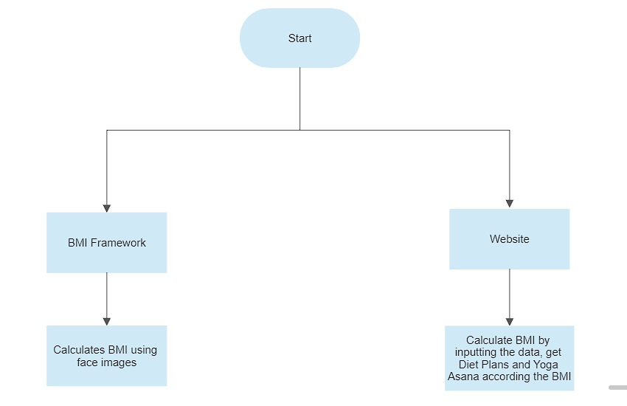

**OVERALL ARCHITECTURE OF BMI WEBSITE**

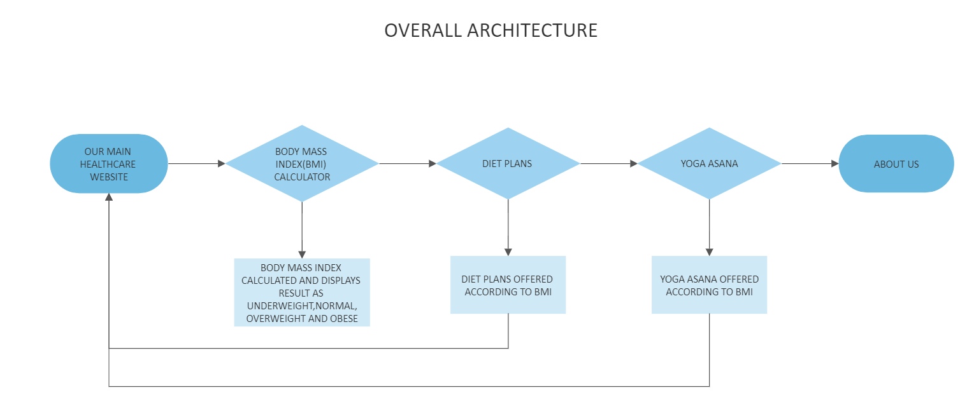

**BMI WEBSITE**

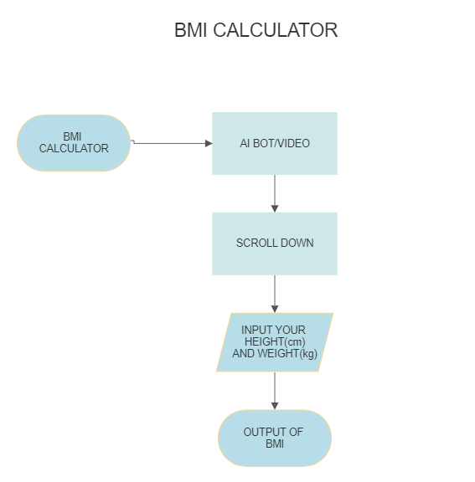

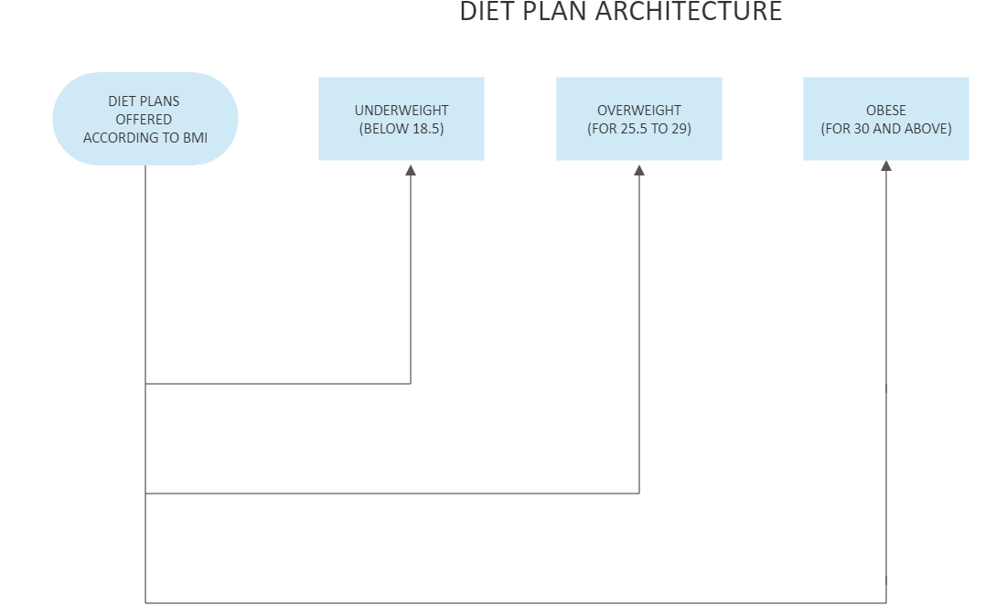

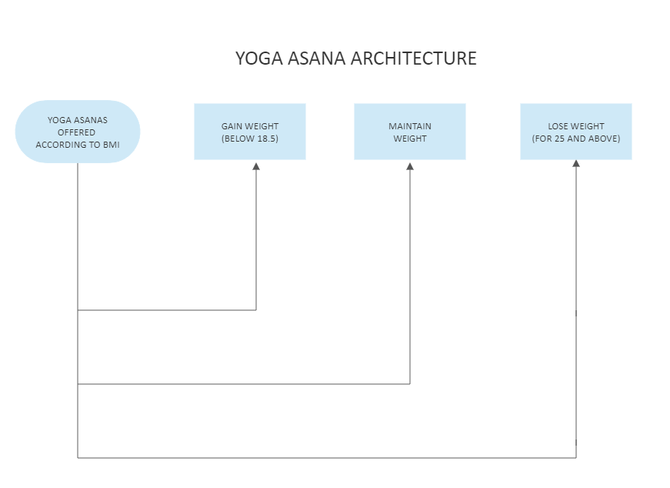

**IMPLEMENTATION**

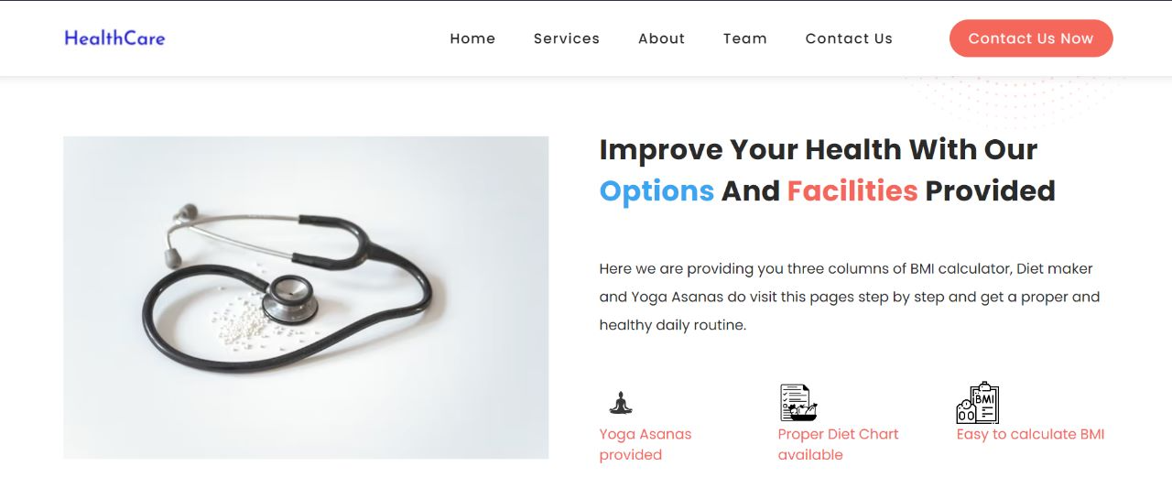

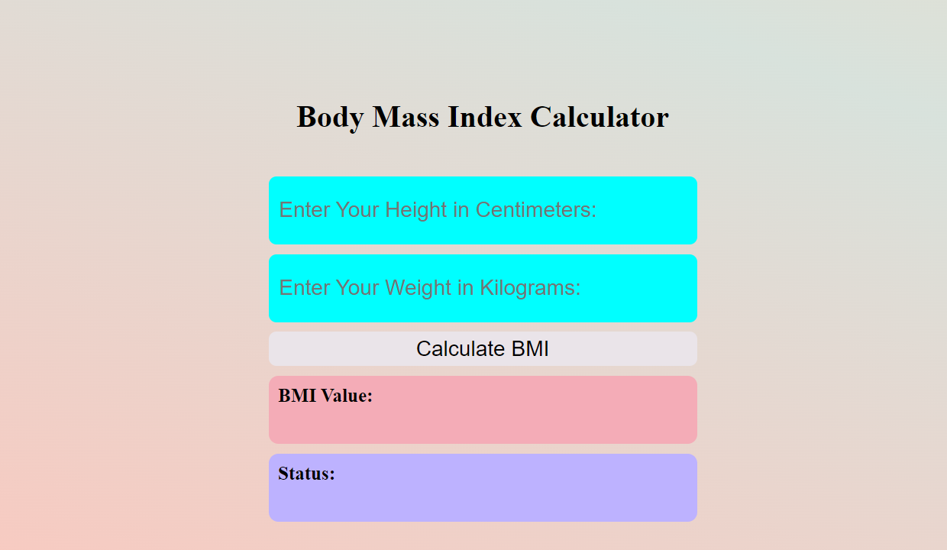



Note:The options in diet charts are GIF



**PERFORMANCE ANALYSIS FOR WEBSITE**

Performance analysis of a website that calculates BMI and offers diet and yoga asanas based on BMI can involve evaluating the website's speed, scalability, reliability, and usability. This can include analyzing factors such as page load time, server response time, database performance, code optimization, caching strategies, and user experience.

Additionally, monitoring and analyzing user engagement metrics, such as bounce rate, time on site, and conversion rate, can provide valuable insights into the effectiveness of the website's design and content

**PERFORMANCE ANALYSIS FOR BMI FRAMEWORK**

Performance analysis of a BMI (Body Mass Index) framework that uses face images can involve assessing the accuracy and efficiency of the model in predicting BMI based on facial features. This can include evaluating the dataset used for training the model, the algorithm used for feature extraction, and the machine learning model used for BMI prediction. Performance analysis can also involve testing the robustness of the model to variations in image quality, lighting, and facial expressions. Additionally, measuring the speed and resource consumption of the model during inference can provide insights into its practicality for real-world applications.

**FUTURE ENHANCEMENTS AND CONCLUSION**

**INTRODUCTION :-**

A website that calculates BMI, diet plan, and yoga asana according to BMI is a useful tool for individuals who want to maintain a healthy lifestyle. The website can use an individual's

height and weight to calculate their BMI and provide information on whether they are underweight, normal weight, overweight, or obese. Based on the BMI result, the website can provide personalized diet plans and suggest yoga asanas that can help them achieve their health goals.

In the future, such a website could become even more sophisticated and offer additional features such as real-time monitoring of dietary intake and physical activity, integration with wearable devices, personalized coaching and motivation, and social networking functionalities. As technology advances, it may also be possible to use artificial intelligence and machine learning algorithms to provide even more accurate and personalized recommendations. Ultimately, the goal of such a website would be to help people improve their overall health and wellbeing by making it easy and convenient to track and manage their nutrition and fitness goals.

**Limitations of BMI**

While a website that calculates BMI, offers diet plans, and suggests yoga asanas based on BMI can be a useful tool for individuals looking to maintain a healthy lifestyle, there are some limitations that should be considered. Here are a few:

* Limited Personalization: The recommendations provided by the website may not take into account an individual's unique medical history, dietary restrictions, and lifestyle habits. As a result, the suggestions may not be optimal for everyone.
* Inaccurate Data Input: The accuracy of the recommendations provided by the website depends on the accuracy of the data entered by the user. If an individual inputs incorrect information, the recommendations may not be accurate.
* Failure to Address Underlying Medical Conditions: A website may not be able to identify underlying medical conditions that can impact an individual's weight and overall health. In some cases, additional medical interventions may be necessary to achieve optimal health outcomes.

Overall, a website that calculates BMI, offers diet plans, and suggests yoga asanas based on BMI can be a valuable tool for promoting healthy lifestyles. However, it's important to recognize the limitations of such a website and supplement it with expert advice and medical attention when necessary.

**FUTURE ENHANCEMENT OF BMI FRAMEWORK**

As technology continues to advance, there are several potential enhancements that could be made to a website that calculates BMI, offers diet plans, and suggests yoga asanas based on BMI. Here are a few possibilities:

* Integration with Wearable Devices: Integration with wearable devices such as fitness trackers and smartwatches could enable the website to provide real-time monitoring of physical activity, heart rate, and other health metrics, which could help individuals better track their progress towards their health goals.
* Artificial Intelligence and Machine Learning: The website could use artificial intelligence and machine learning algorithms to provide even more personalized and accurate recommendations based on an individual's specific health profile, including their BMI, medical history, dietary preferences, and physical activity level.
* Expanded Nutritional Information: The website could provide more detailed nutritional information about specific foods and supplements, as well as recommendations for vitamins and minerals based on an individual's BMI and other health metrics.
* Social Networking Functionalities: The website could include social networking functionalities that enable users to connect with other individuals who have similar health goals and share tips, advice, and motivation.
* Telehealth Services: The website could offer telehealth services that allow users to consult with qualified healthcare professionals who can provide additional guidance and support.

**CONCLUSION OF BMI WEBSITE**

In conclusion, a website that calculates BMI, offers diet plans, and suggests yoga asanas based on BMI can be a valuable tool for individuals looking to maintain a healthy lifestyle. While there are limitations to the accuracy of the recommendations and the personalization provided, it can be a useful starting point for individuals looking to improve their health.

As technology continues to advance, there are many potential enhancements that could be made to such a website. Integration with wearable devices, artificial intelligence and machine learning, and social networking functionalities are just a few examples of potential future enhancements. Ultimately, a website that calculates BMI, offers diet plans, and suggests yoga asanas based on BMI has the potential to become an even more powerful tool for promoting healthy lifestyles and preventing chronic diseases as technology continues to evolve

**CONCLUSION FOR BMI FRAMEWORK**

In conclusion, a BMI framework using face is a promising new technology that has the potential to revolutionize how we measure and monitor body composition. It offers a non-invasive, low-cost, and convenient method for estimating an individual's BMI, which can be an important indicator of their overall health.

While the accuracy of the estimates can vary depending on the quality of the data , a BMI framework using face is a useful starting point for individuals looking to monitor their health and make lifestyle changes. The framework has the potential to provide recommendations and track progress over time, which can be valuable for individuals looking to maintain a healthy weight.

As with any new technology, there are limitations and challenges that need to be addressed, such as ensuring the accuracy of the estimates, protecting personal data and privacy, and ensuring that the technology is accessible to all individuals regardless of their age, gender, or ethnicity.

Overall, a BMI framework using face is a promising development that has the potential to help individuals lead healthier lives. As the technology continues to evolve and improve, it could become an even more accurate and powerful tool for promoting healthy lifestyles and preventing chronic diseases.

**REFERENCES**

**1.** **.https://www.lybrate.com/topic/weight-gain-diet-chart**

**2.https://www.qtestdiagnostics.com/diet-pune/ 3.https://www.chandigarhayurvedcentre.com/blog/weight-loss-weekly-diet-plan/**

**4.** [**https://medium.com/@leosimmons/estimating-body-mass-index-from-face-images-using-keras-and-transfer-learning-de25e1bc0212**](https://medium.com/@leosimmons/estimating-body-mass-index-from-face-images-using-keras-and-transfer-learning-de25e1bc0212)

**5. https://pypi.org/project/pip/**